

(ISO 9001:2015 Certified), Accredited with ‘A’ Grade by NAAC

: 08258 - 281039 – 281263, Fax: 08258 – 281265

### Department of Computer Science and Engineering

B.E. CSE Program Accredited by NBA, New Delhi from 1-7-2018 to 30-6-2021

Report on Mini Project

Voting Management System

#### Course Code : 18CS502 Course Name : Database Management System

##### Semester:VSEM Section: C

**Submitted To:**

## Ms. Ankitha A Nayak Assistant Professor

## Department of Computer Science and Engineering

**Submitted By:**

**Saurav N Shetty (4NM18CS160)**

**Shashank (4nm18cs165)**

**Date of submission: 26/12/2020**

#### Signature of Course Instructor

# ABSTRACT

VoteHub is a simple online election management system which enables users to create and participate in elections.

It provides a way to simplify the election process by allowing users of this web application to create their own elections. The candidates and voters can participate in elections by creating an account.

The main aim of VoteHub is to provide a platform to create and participate in different elections using the same web application. This can be used by small organization, schools, colleges etc. to conduct quick elections easily.

# TABLE OF CONTENTS

TitlePage i

Abstract ii

TableofContents iii

pg no

Introduction…………………………………………………………………………………… 04

Objectives …………………………………………………………………………………….. 05

Literature Review ……………………………………………………………………………. 06

Methodology ………………………………………………………………………………….. 07

Implementation Details……………………………………………………………………… 08

Results…………………………………………………………………………………………. 10

Conclusion and Future Scope …………………………………………………………….. 15

References ……………………………………………………………………………………. 15

# INTRODUCTION

Voting as we all know is often associated with politics and is done more often using the manual approach where voters queue up to vote for their choices. Manual voting without any doubt exhibits chances of voting malpractices and other negative vices. Those and many other reasons triggered the need to shift from the manual voting system to a more sophisticated digitalized voting platform. Today, voting does not only stop at politics but also extends to other areas of human endeavors such as entertainment, sports, business, Student unions, classrooms, fashion and style and so on and so forth. A lot of these elections do no require the physical presence of the voter, for such cases we have tried to provide a convenient approach to elections.

# OBJECTIVES

* Provide a convenient way of creating elections.
* Remove malpractices caused by individuals in a traditional voting system.
* To remove the time restriction problems faced by voters.
* Efficient management of time for the process of voting in elections.
* Remove the requirement of the physical presence of participants in an election.
* Provide a secure way to manage elections online.

# LITERATURE REVIEW

One basic feature of democracy that cuts across all divides of people is the act of election. Democracy thus encourages individual freedom according to the rule of law, so that people may behave and express themselves as they choose. This not only gives people a chance to choose their leaders, but also to freely express their views on issues. In response to the 1948 Universal Declaration of Human Rights which puts import on the necessity of free elections, nations aim at new and improved voting procedures which are of relevance to elections in the 21st century (Salomonsen, 2005). With the passage of time, voting, which was mainly manual, has been influenced by Information Technology, with debates arising about the relevance or not, of computerized/online voting (Shamos, 2004 and Cranor, 2011). Nevertheless, it is impossible to completely rule out the need for technology and electronic voting, with the growing number of eligible voters and manual ballot papers involved (Hunter, 2001). Smith andClark (2005) indicate that electronic voting is the next logical step in applying online information-gathering and retrieval technologies to e-government. The project for this paper evolved based on this theory.

There are many electronic voting systems which requires biometric authentication, but our aim is to make the process of election simple and easy for the participants while also retaining the security features.

# 

# METHODOLOGY

The development phase of the project was done using the MVC design pattern. MVC stands for model, view and controller. The Model View Controller (MVC) design pattern specifies that an application consist of a data model, presentation information, and control information. The pattern requires that each of these be separated into different objects.

The Model contains only the pure application data, it contains no logic describing how to present the data to a user. This was implemented by creating a model package which represents the entities used in our project.

The View presents the model’s data to the user. The view knows how to access the model’s data, but it does not know what this data means or what the user can do to manipulate it. The web pages created using HTML in our web app represents the view of our project.

The Controller exists between the view and the model. It listens to events triggered by the view (or another external source) and executes the appropriate reaction to these events. Since the view and the model are connected through a notification mechanism, the result of this action is then automatically reflected in the view. The controllers in our project is mainly used to handle requests from the views and dynamically change the views by accessing the data in the model. We implemented a separate service layer between the controller and the model.

The service layer implements the business logic used in our project.

# IMPLEMENTATION DETAILS

1. **Front-End**: HTML5, CSS3, JS, BOOTSTRAP
2. **Back-End**: Java Spring Boot
3. **Database**: MySql
4. **Software tools**: Spring Tools Suite (IDE)

**Database Implementation**

The database was created using java persistence API which uses object relational mapping (ORM) to generate the relations used in the database from the classes defined as entities in java.

* Schematic Diagram

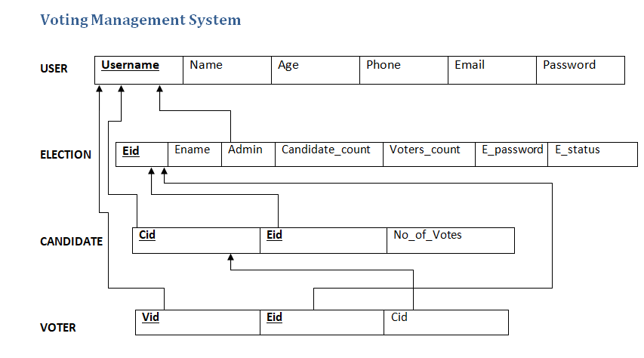

Users : This table is used to store the user account information

Election : This table is used to store information about election. A new entry is inserted whenever a user creates an election.

Candidate : This table relates a candidate (user) to their respective election.

Voter : This table relates a voter (user) to the election in which they voted. A new entry gets inserted whenever a user votes in a particular election.

**RESULTS**

* Users can easily create and end elections using the web application.
* Users can vote in any election by finding the same in the home page.
* Elections are password protected. Users need to know the password in order to vote or view the election results.
* Election passwords are set by the user who created them.
* The user who created the election can end the same at any time by clicking on the show results button for a particular election.
* The user can find the elections he/she created in the my elections page.

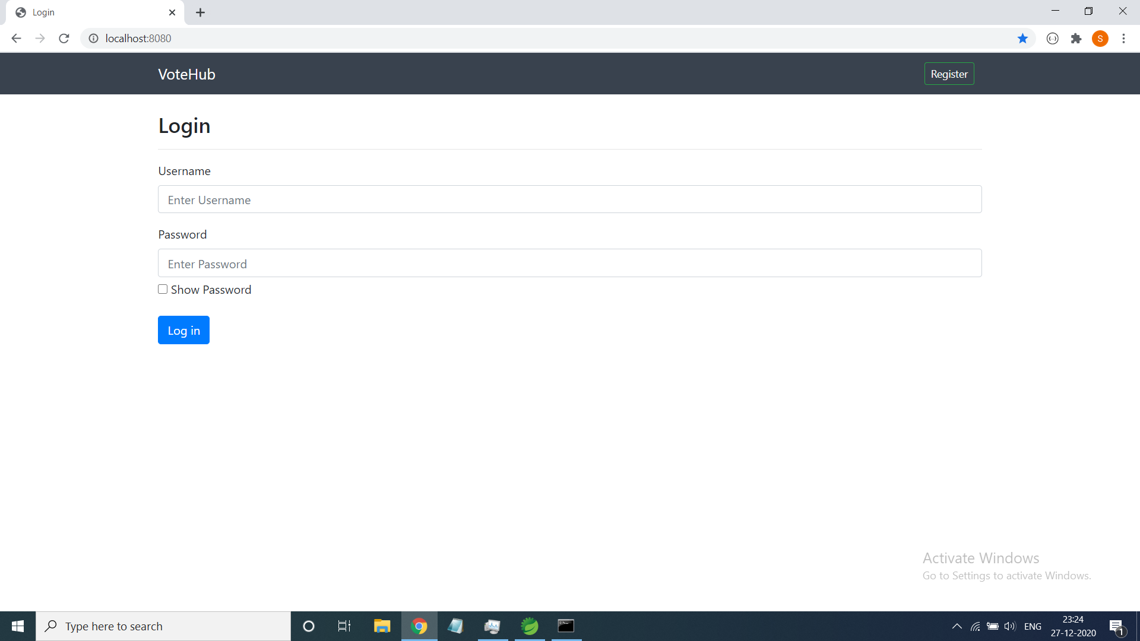

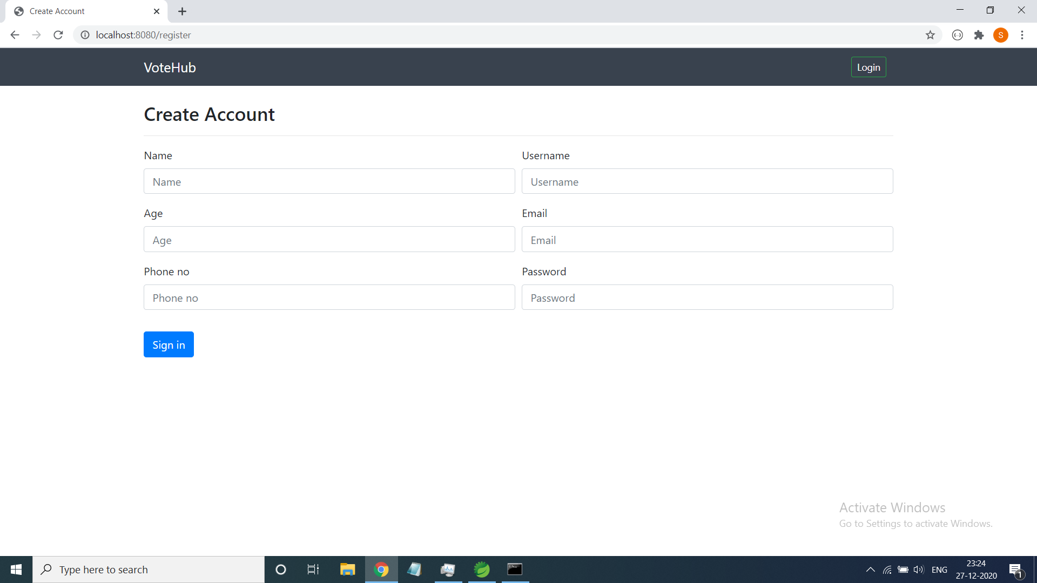

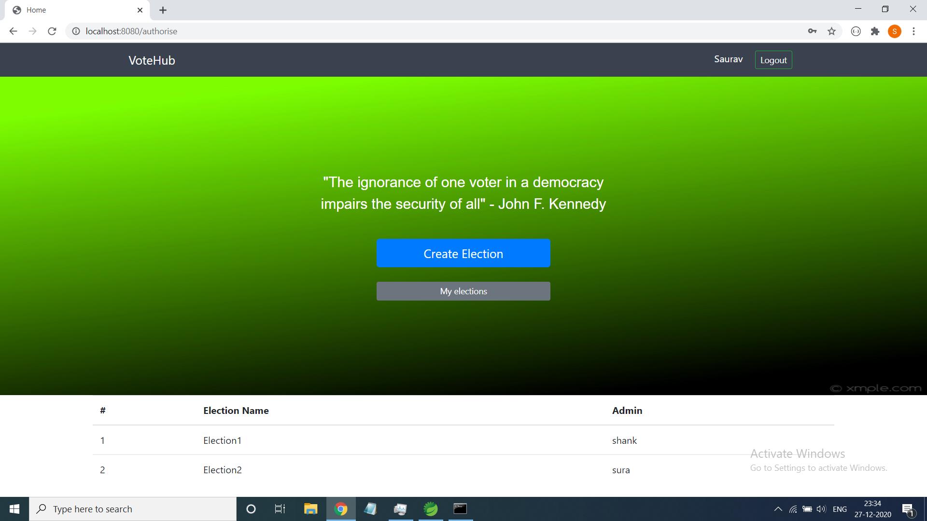

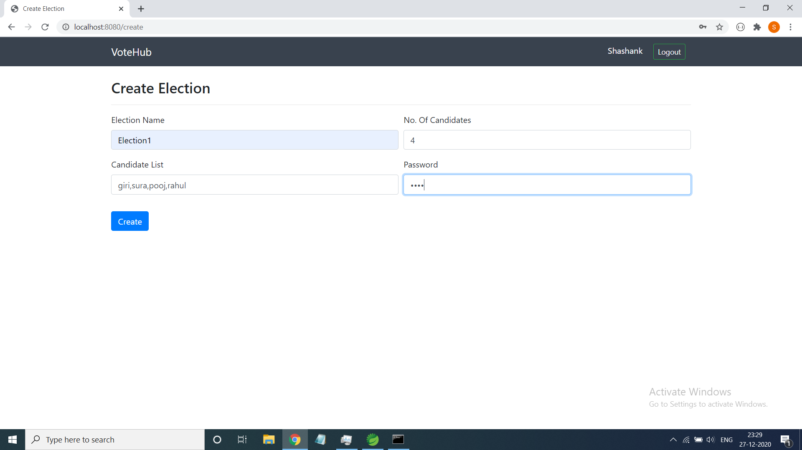

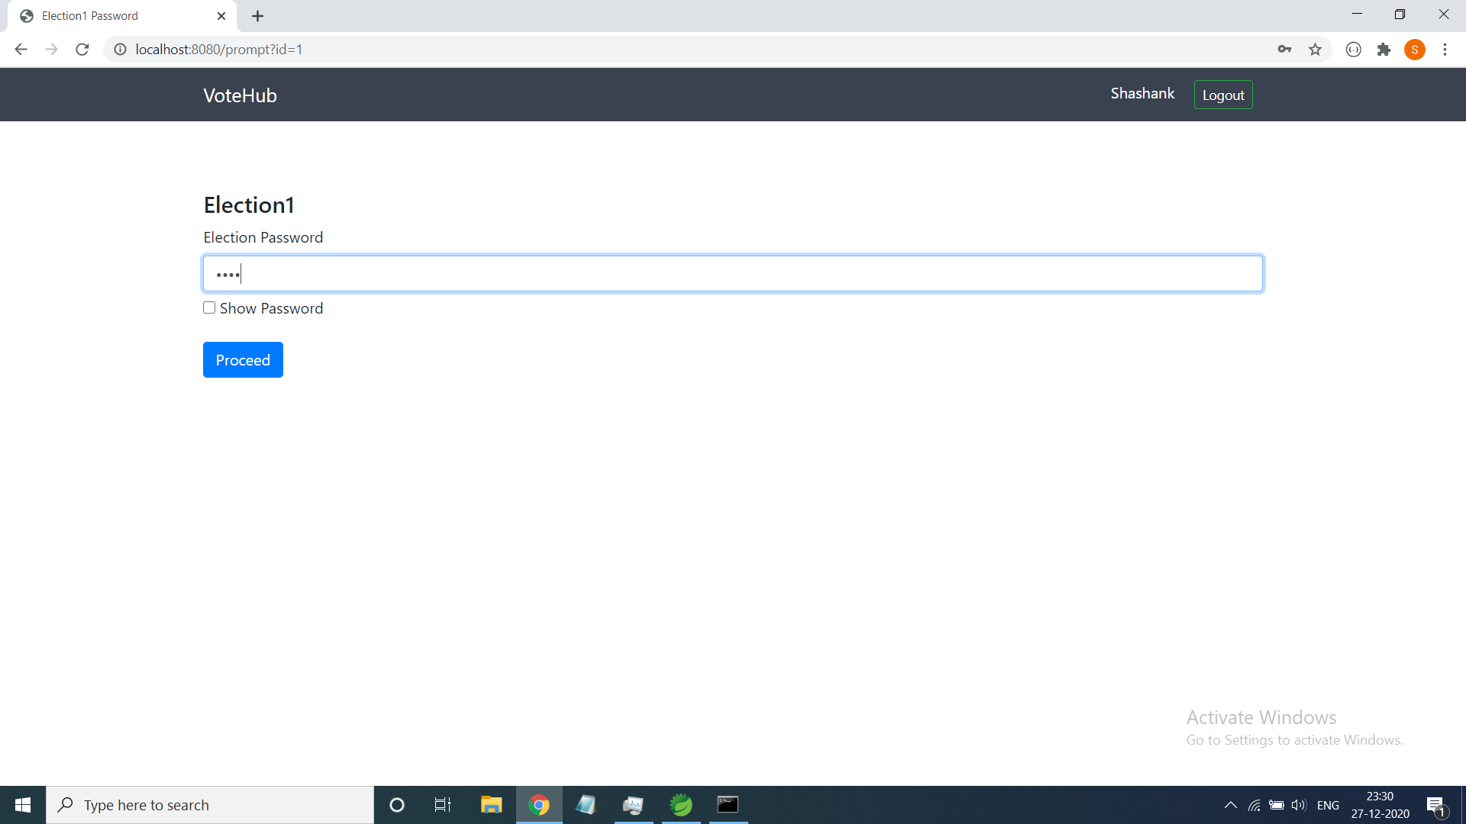

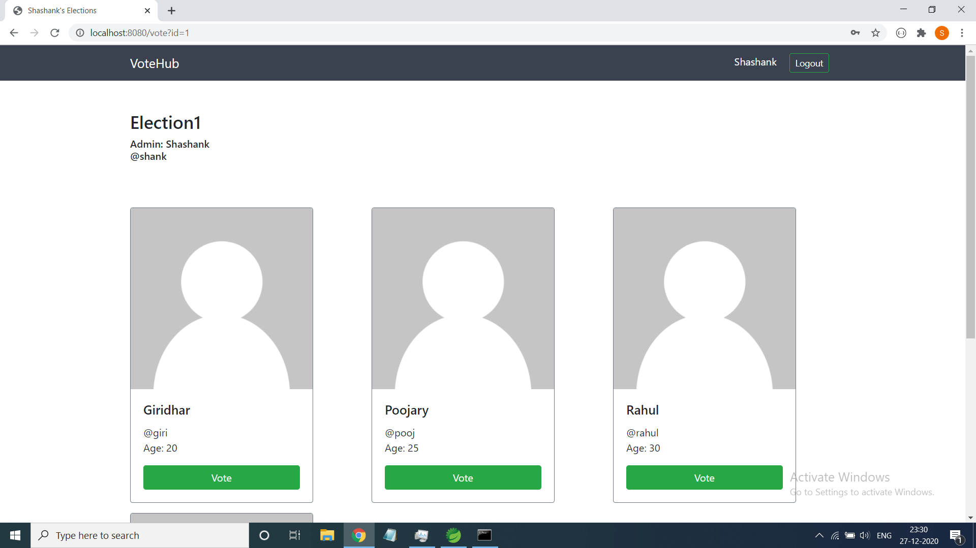

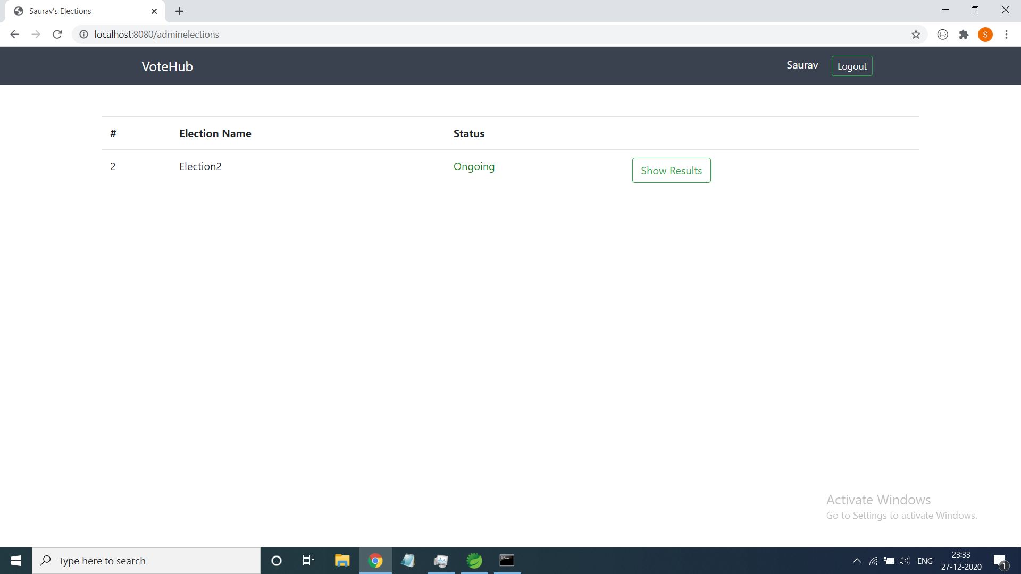

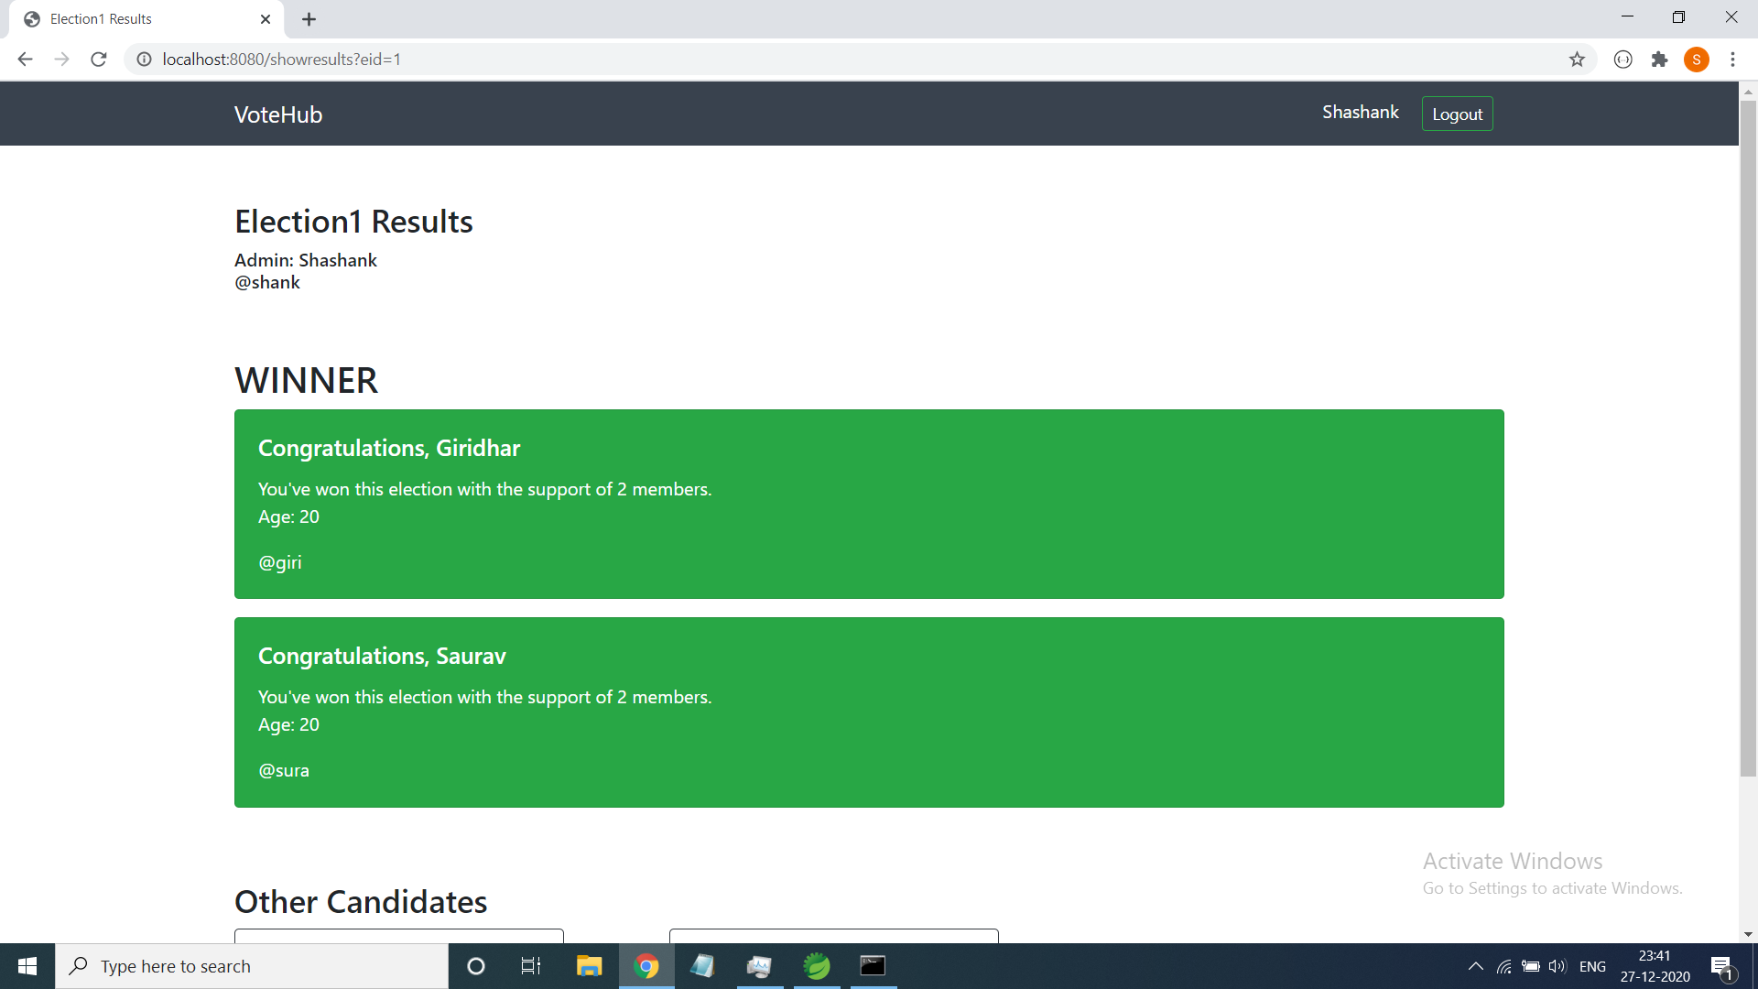

# CONCLUSIONS AND FUTURE SCOPE

The scale of the project can be improved further to support a large number of users. The authentication process involved in elections can also be improved there by increasing the security of elections.

Given the current situation of our world, there might be a situation where everything must be done remotely. This was our attempt which supports the same cause.

Online Voting affords increased levels of general Election or Ballot security compared with traditional Polling Booth or Postal Voting processes. Depending upon the information available through an organization’s voter database, and also depending upon the level of security required, varying levels of voter authentication may be applied. Obviously, the higher the level of authentication, the greater the level of security.

# REFERENCES

1. <https://www.w3schools.com>
2. https://spring.io
3. https://getbootstrap.com